**Vrinda Store Report**

**Objective**

Vrinda store wants to create an annual sales reports for 2022.

So that, Vrinda can understanding their customers and grow more sales in 2023.

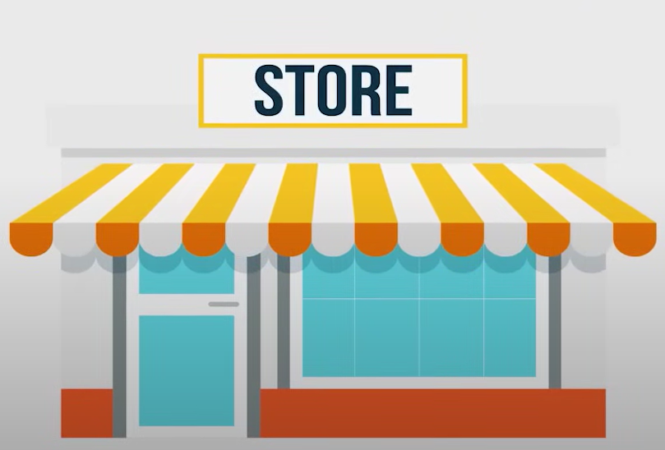

**Sample Questions**

**1. Compare the Sales and Orders using single chart.**

**2. Which month got the highest sales and orders?**

**3. Who purchased more-men or women in 2022?**

**4. What are different order status in 2022?**

**5. List top 5 states contributing to sales?**

**6. Relation between age and gender based on number of Orders.**

**7. which channel is contributing to maximum sales?**

**8. Highest selling category?, etc.**

**Process**

**1. Data Cleaning**

**\* Replace M to Men and W to Women in column Gender.**

**\* Replace one to 1 and two to 2 in column Quantity.**

**2. Data Processing**

**\* Creating Age Group column. If age > 50 then “Senior”, age >30 and age < 50 then “Adult”,**

**Age < 30 then “teenager”.**

**Data Visualization**

**1. Orders: Age Vs Gender**

|  |  |  |
| --- | --- | --- |
| **Count of Order ID** | **Column Labels** |  |
| **Row Labels** | **Men** | **Women** |
| Adult | 14.91% | 33.32% |
| Senior | 5.72% | 13.31% |
| Teenager | 9.95% | 22.79% |

|  |  |
| --- | --- |
| **Row Labels** | **Count of Order ID** |
| Ajio | 6.22% |
| Amazon | 35.48% |
| Flipkart | 21.59% |
| Meesho | 4.50% |
| Myntra | 23.36% |
| Nalli | 4.78% |
| Others | 4.06% |

**2. Orders: Chennel**

3. Orders: Age Vs Gender

|  |  |  |
| --- | --- | --- |
| **Count of Order ID** | **Column Labels** |  |
| **Row Labels** | **Men** | **Women** |
| Adult | 14.91% | 33.32% |
| Senior | 5.72% | 13.31% |
| Teenager | 9.95% | 22.79% |

**4. Orders Status**

|  |  |
| --- | --- |
| **Row Labels** | **Count of Order ID** |
| Cancelled | 844 |
| Delivered | 28641 |
| Refunded | 517 |
| Returned | 1045 |

**5. Order Vs Sales**

|  |  |  |
| --- | --- | --- |
| **Row Labels** | **Sum of Amount** | **Count of Order ID** |
| Jan | 1820601 | 2702 |
| Feb | 1875932 | 2750 |
| Mar | 1928066 | 2819 |
| Apr | 1829263 | 2685 |
| May | 1797822 | 2617 |
| Jun | 1750966 | 2597 |
| Jul | 1772300 | 2579 |
| Aug | 1808505 | 2617 |
| Sep | 1688871 | 2490 |
| Oct | 1666662 | 2424 |
| Nov | 1615356 | 2383 |
| Dec | 1622033 | 2384 |

**6. Sales: Men Vs Women**

|  |  |
| --- | --- |
| **Row Labels** | **Sum of Amount** |
| Men | 7613604 |
| Women | 13562773 |

**Vrinda Store Dasboard Report 2022.**

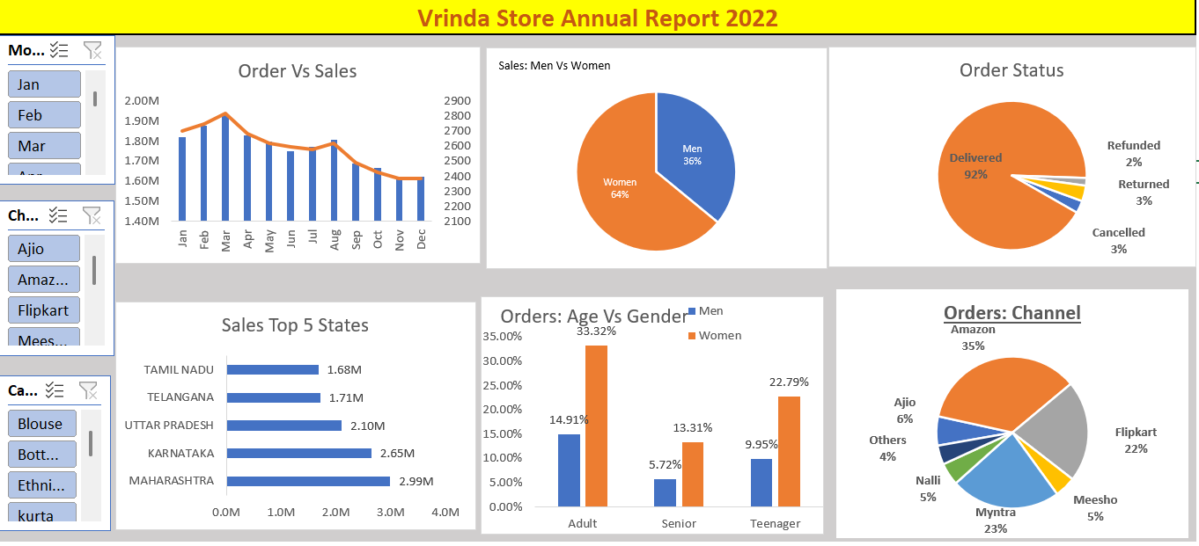

**Sample Insights**

**1. Women are more likely to buy compared to men (65%)**

**2. Maharashtra, Karnataka and Uttar Pradesh are the top 3 States (35%)**

**3. Adult age group (30-40 yrs) is max contributing (50%)**

**4. Amazon, Flipkart and Myntra channels are max contributing (80%)**

**Final Conclusion to improve Vrinda store sales:**

**Targeting women customers of age group (30-49 yrs) living in**

**Maharashtra, Karnataka and Uttar Pradesh by showing**

**Ads/ offer/ coupons available on Amazon, Flipkart and Myntra.**